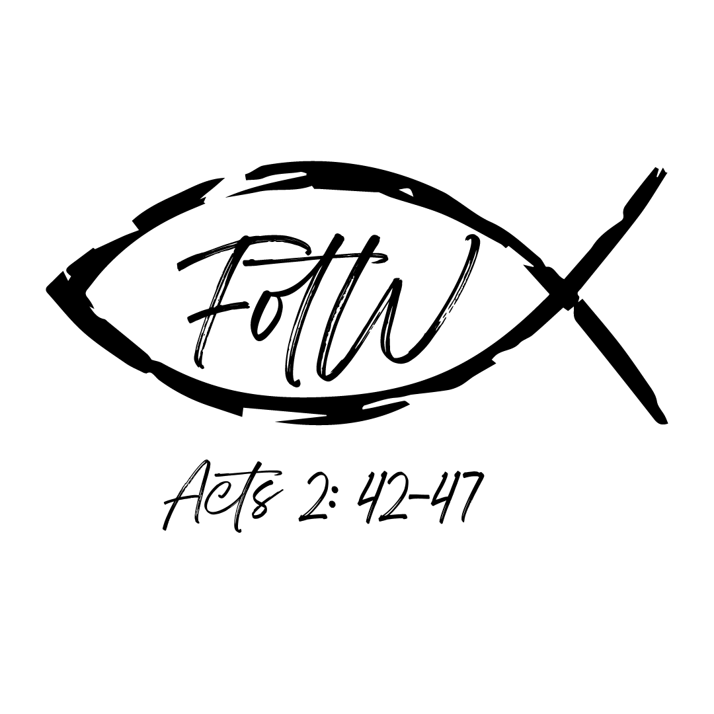Followers of the Way- Early Church of Acts Discipleship Groups

KEY TOPIC:

[Key Points]

[Bible verses]

[Other Graphics or Words]

LESSONS LEARNED

Short Lesson #1

Short Lesson #2

Short Lesson #3

Memory Verse

NOTES
________________________________________________________________________________________________________________________________________________________________________________________________________________________________________________________________________________________________________________________________________________________________________________________________________

TABLE TALK

Short Question #1

Short Question #2

Short Question #3

